SQL VERSE

Rojo. Jofel - Homepage Design and html, css, and JavaSript code

Lasaca, Jeff Jude - Login Page Design and html, css and JavaSript code

Daan, Jamaica - Advanced Page Design, Layout of Advanced and Fundamental topics and html code

Tinoy, Mea Jane - Fundamental Design and html code.

First thing, is when you visit our website you can view only the fundamental topics if you didn’t sign in or register, when you are registered you can now access the remaining topics like advanced and you can also access the additional features of our website like the exercises. Exercises like the quiz can enhance your learning.

The Homepage typically begins with an introduction to SQL, explaining its definition and significance in database management.

The Fundamentals Page defining it as Structured Query Language and highlighting its importance in managing relational databases. It covers basic commands like SELECT, WHERE, AND, and DELETE, explaining how each is used to interact with database records.

Advance Page usually covers advanced joins, including right join and inner joins, along with scenarios where they are applicable. It may also address subqueries in more detail, discussing correlated subqueries and their performance implications.

Saturday November 9, 2024

First week of development of the website. We tried some testing about the homepage and the log in page.

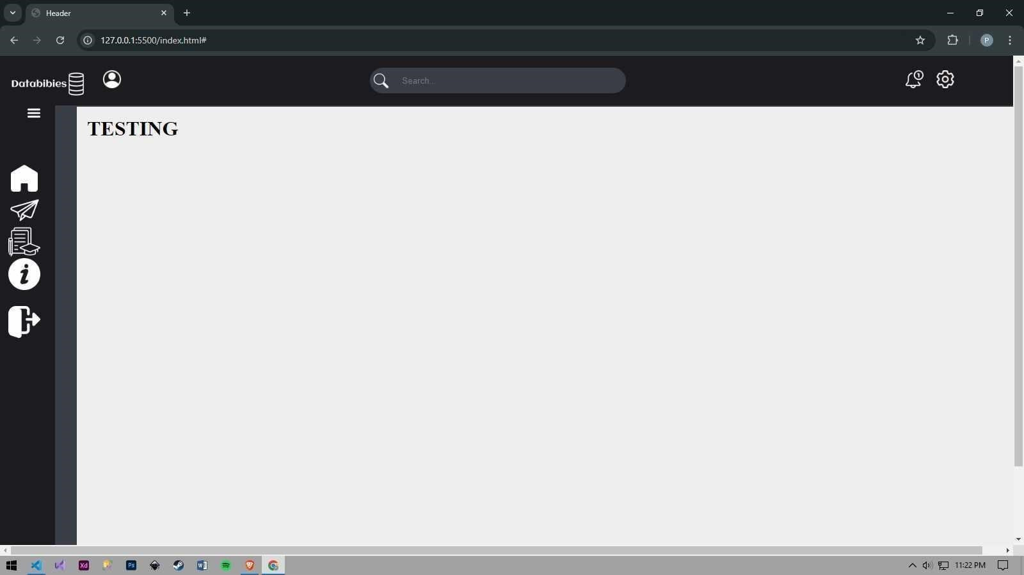

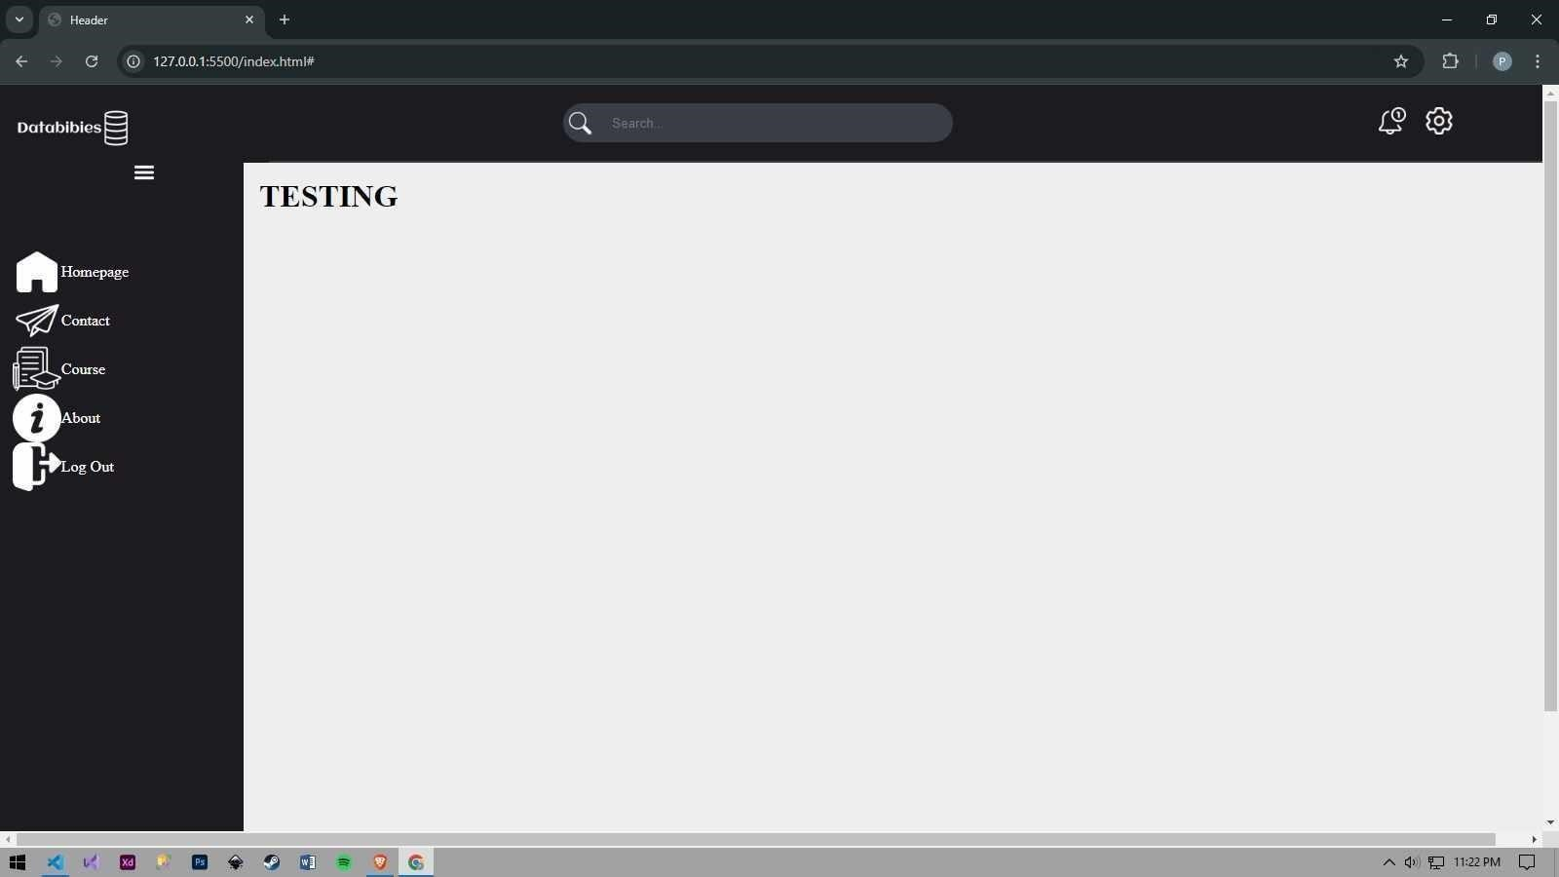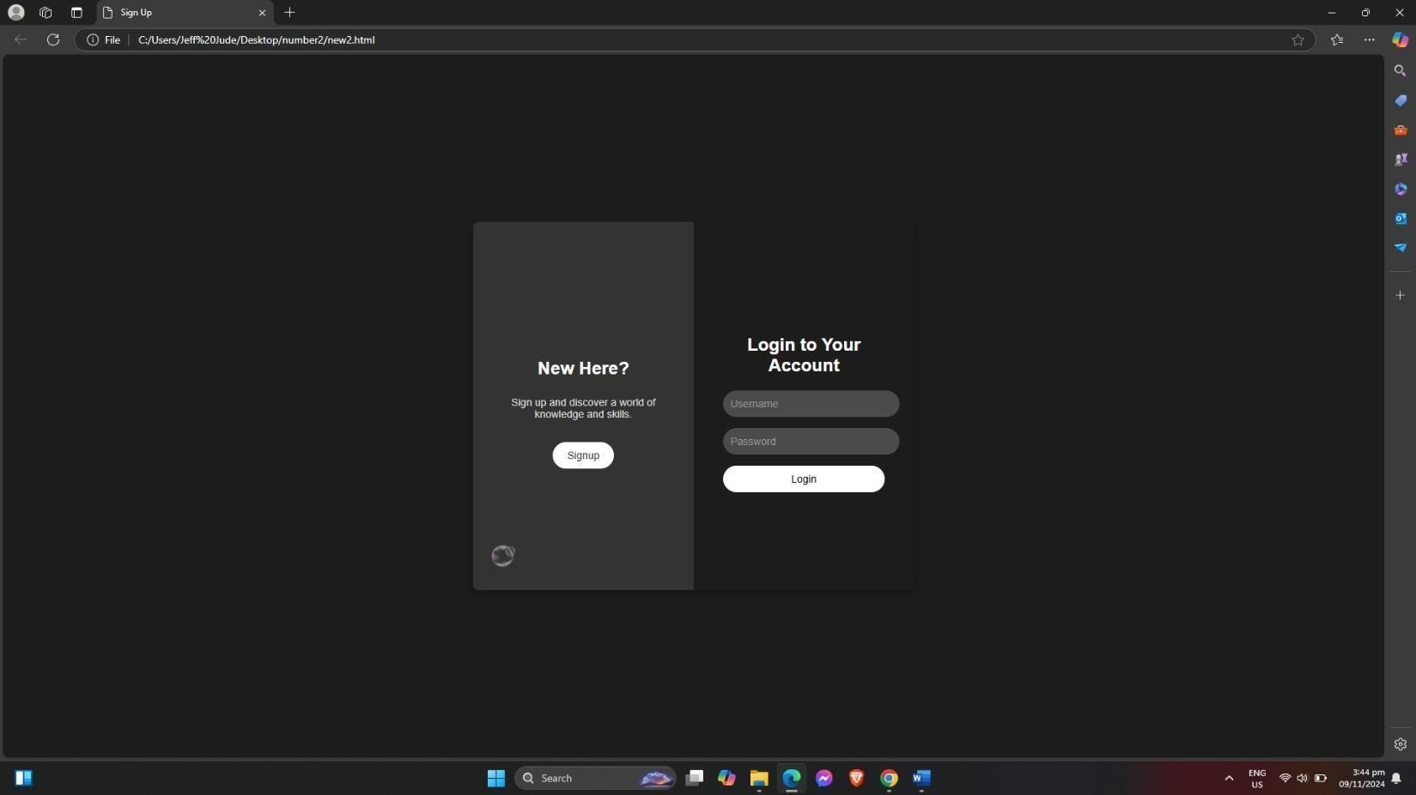

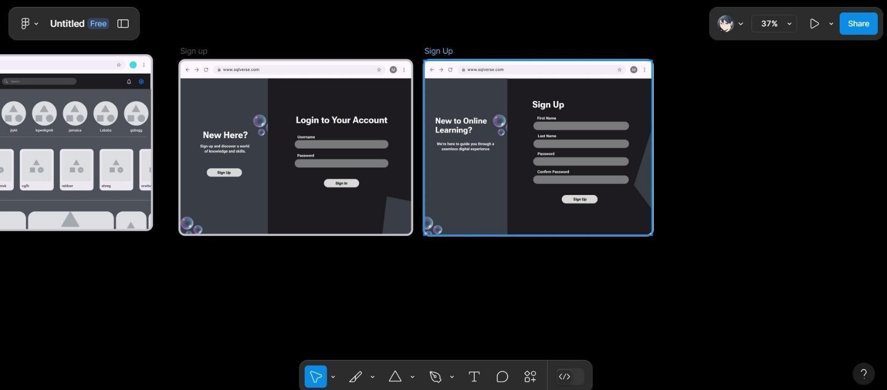

November 16, 2024

We tried another layout that matches out topic which is the SQL.

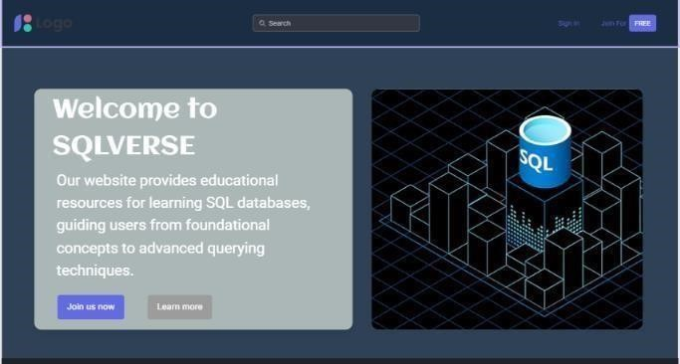

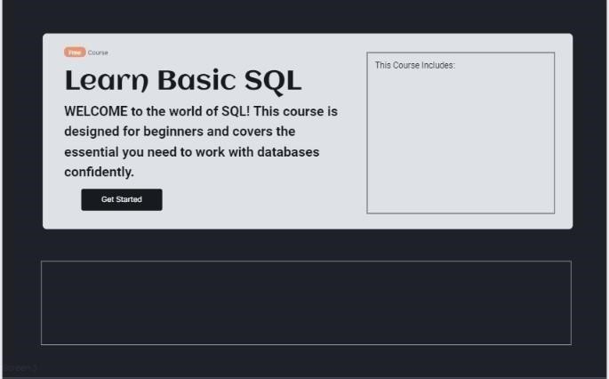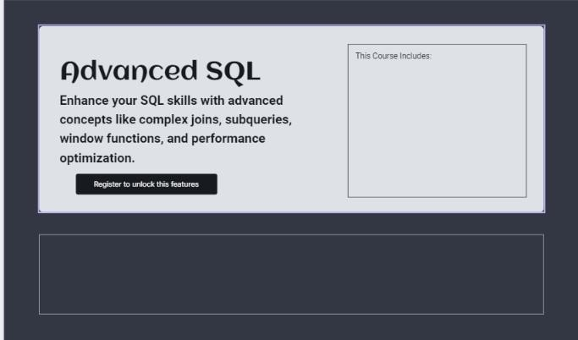

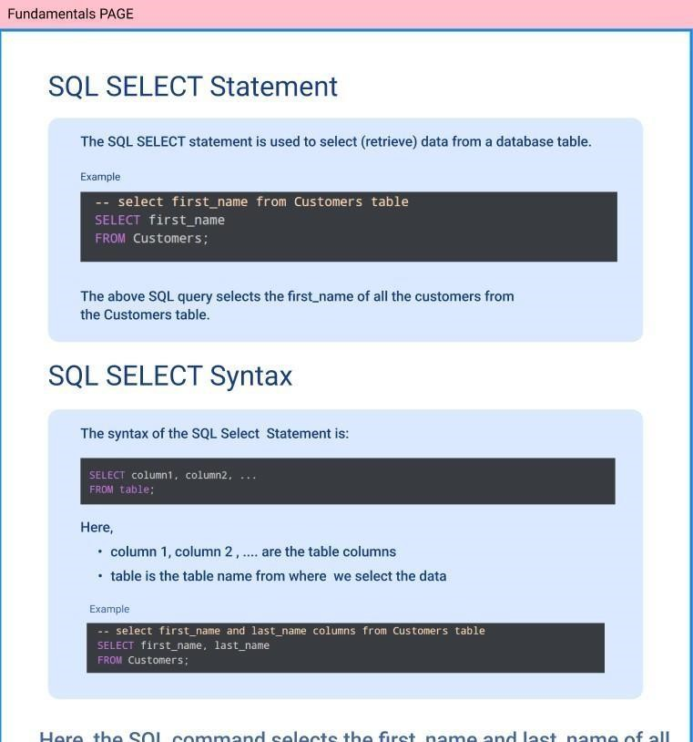

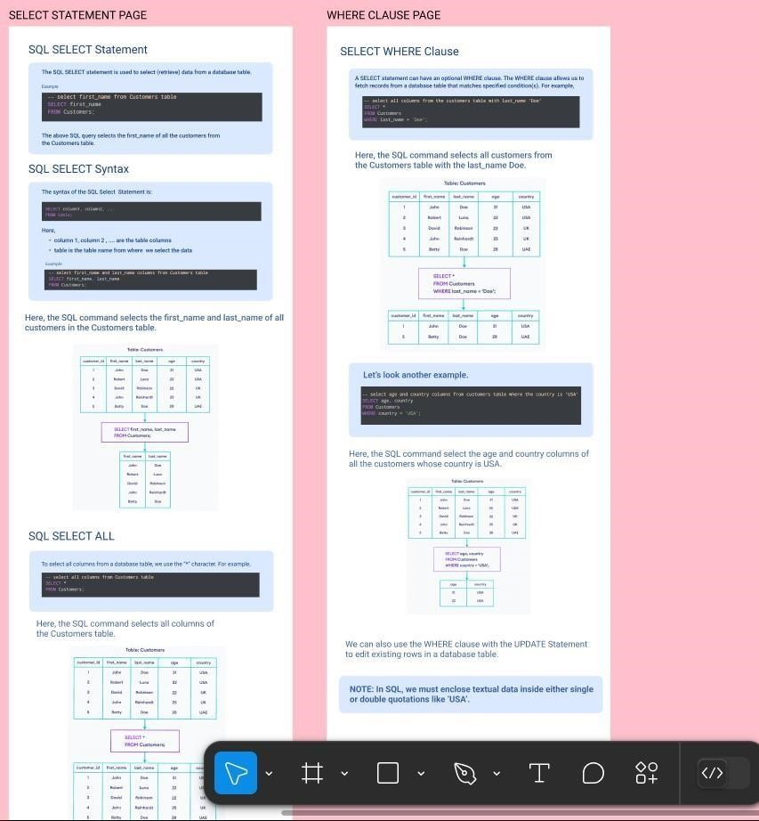

Saturday November 26, 2024

We added some animation in the home page so that it will not be boring to the user and we change the home page layout. We added the fundamental and the advance topics.

.

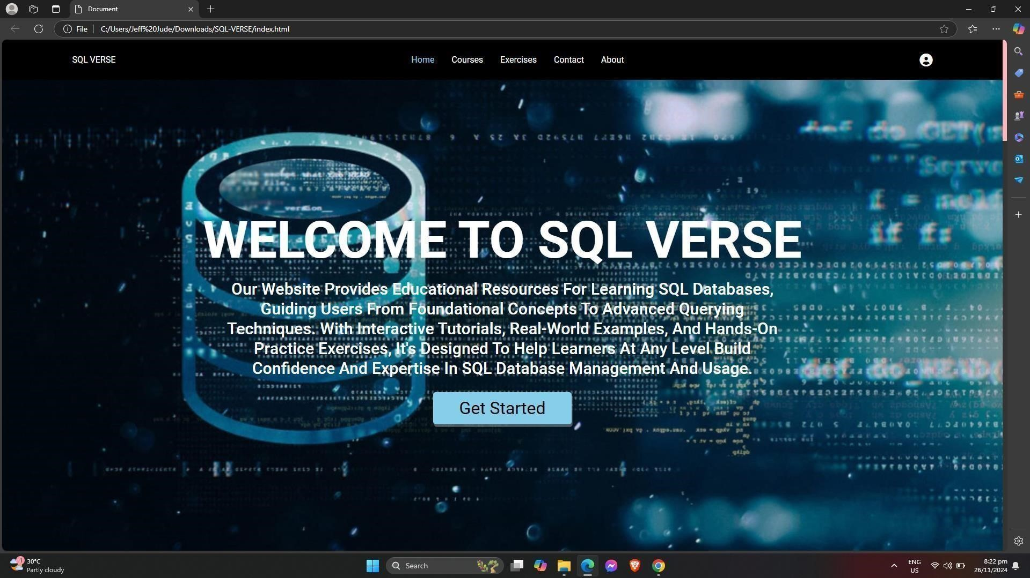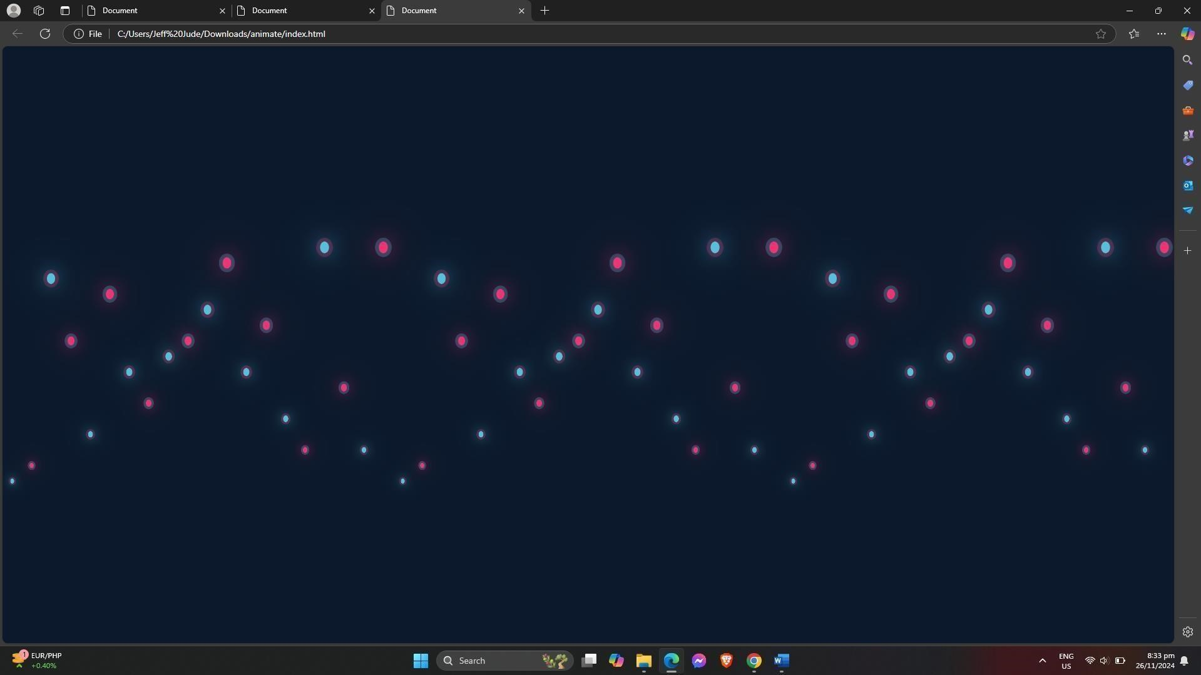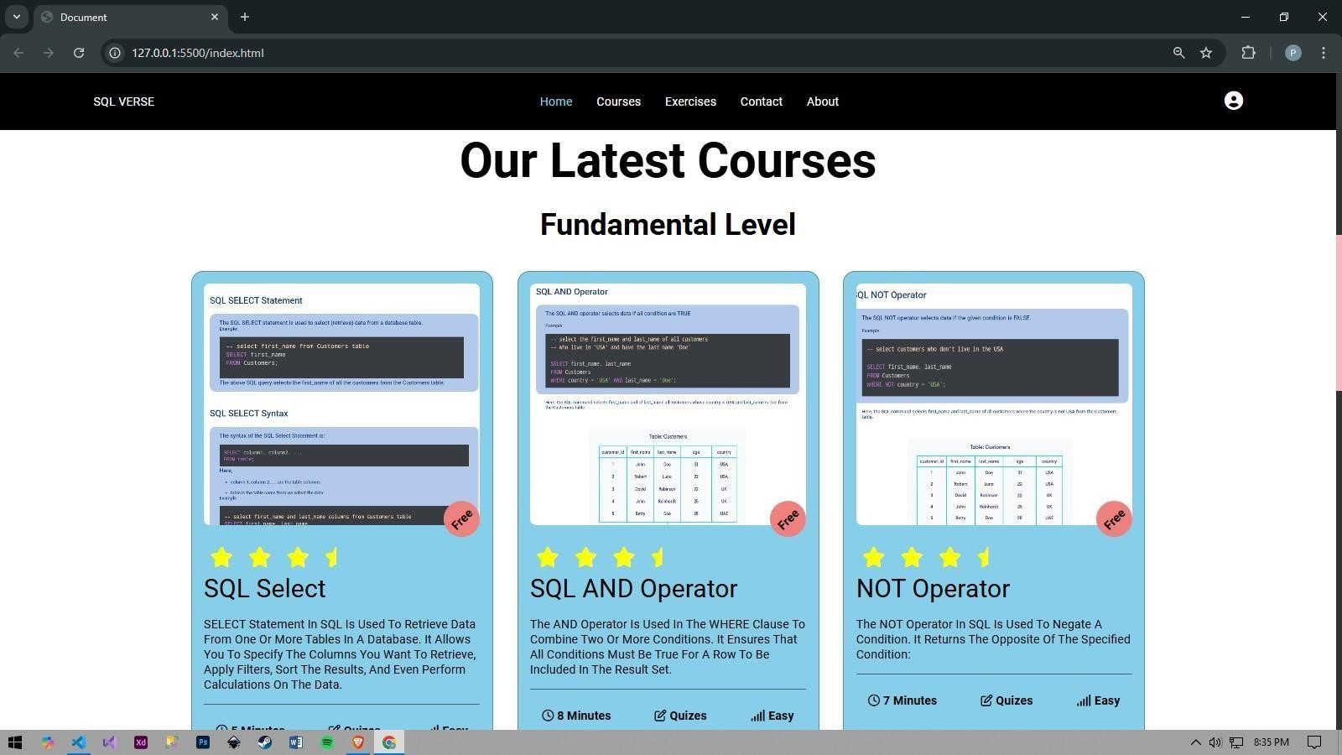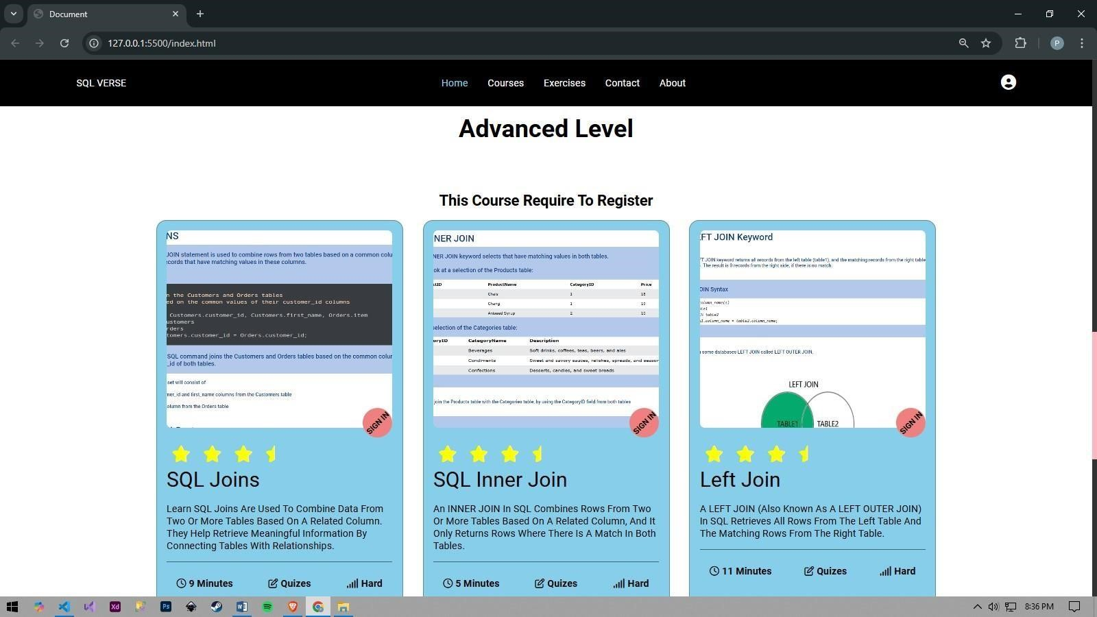

December 3, 2024

We finalized all the pages and we added some unique features which the quiz page where you can enhance your learning about the topic. Here is the final result.

